Fontys Git Tutorial



Last version: 10-11-2020

Authors:  
Tim de Laat  
Kristian Snel

Contents

What is Git and why would you use it? 3

Git basics 4

2.a Git Technical 4

2.b Git Management 4

3. Git Advanced 4

# What is Git and why would you use it?

Git is the answer to the call of software developers struggling to work on large projects with large teams. Git allows a team to keep a clear overview of the changes made to files. Git is a so-called distributed version control system. Using a version control system allows a team to keep a log of changes made to the files in the past. Therefore, allowing every member of the team to see how the document progresses.

***Did you know?***

*Git was created in 2005 by Linus Torvalds. Torvalds is also famous for his creation of the Linux Kernel.*

Git is not only useful for teams but also for individuals. A project may span a long amount of time. It can get difficult to keep track of project files and file history. Git provides a set of tools to see previous project versions, or test extra functionality parallel to the original project ensuring the safety of the original project.

This document features as a guideline to Git and how you as a Fontys student can incorporate Git in your standard workflow to prevent issues such as data loss and miscommunication and in general help with maintaining an organized project structure.

This Git tutorial will be split into 4 different tutorials namely:

|  |  |
| --- | --- |
| Tutorial | Aimed at |
| Git basics | Everyone |
| Git technical | Project members |
| Git management | Project management |
| Git advanced | Those who want to use Git to its maximum potential |

# Git basics

Preface

## Installation

<https://desktop.github.com/>

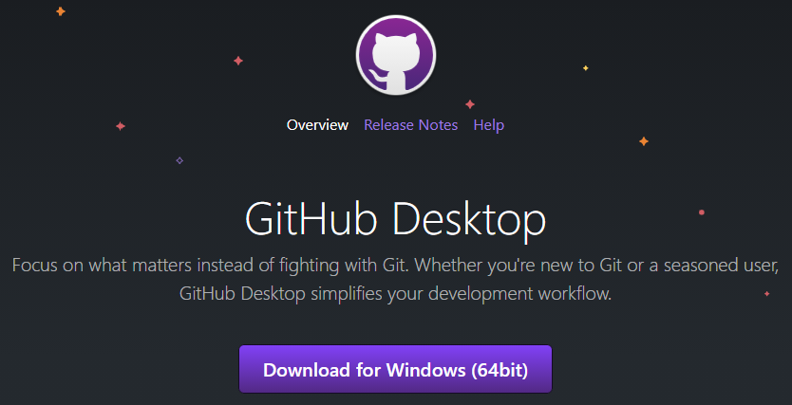

git init

git clone git pull

git config --global user.name git config --global user.email

git touch documentname

git add wildcard *.html all .

git status

git commit -m 'description what changed' (Waar is die -m ook al weer voor?)

git push

Branching

git branch branchname

git checkin git checkout

gitmerge branchname 'describe merge'

# Git Technical

# Git Management

# Git Advanced